The 2948 Free Fly Schedule

Nov 23 – Anvil Aerospace
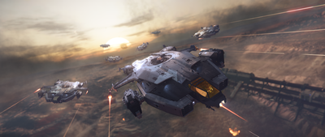
Arrow: [REDACTED]
Gladiator: A ruggedly built two-person dive bomber.
Hornet F7C: Tough and dependable, the F7C is a multipurpose medium fighter.
Hornet F7C Wildfire: Special Edition of the F7C Hornet with custom livery and loadout geared for Arena Commander.
Hornet F7C-R – Tracker: Sacrificing a turret for an advanced radar dome, the Hornet Tracker seeks what is hidden.
Hornet F7C-S – Ghost: Stealthy, quiet, silent – the Ghost haunts an area by keeping a low profile.
Hornet F7C-M – Super Hornet: A two-seater multi-purpose medium fighter with a heavier loadout.
Hurricane: A heavy fighter with excessive loadout, including a turret that punches through shields and defenses.
Terrapin: Heavily armored ship with a sophisticated scanner, ideal for recon and exploration.
Valkyrie: A heavily armed multirole gunship and dropship.

Nov 24 – Roberts Space Industries
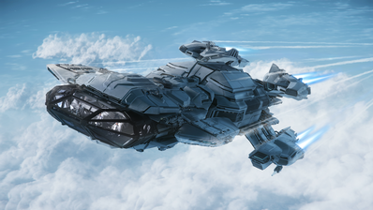
Aurora ES: A descendent of the X-7, this is the perfect choice for new ship owners. Versatile and intuitive.
Aurora LN: For the combat focused, the Aurora LN comes with bigger shields and larger weapons that pack a punch.
Aurora LX: The Aurora Deluxe, adding luxury and comfort for long stretches in the deep black.
Aurora MR: A balance of function and performance, the Aurora MR comes with cargo capacity and guns to ensure freight gets there safely.
Constellation Andromeda: A multicrew freighter with modular design, the RSI Andromeda is one of the most iconic ships in the verse.
Constellation Aquila: Exploring the stars and distant horizons with a rover, sensor suite and a redesigned cockpit offering max visibility.
Constellation Phoenix: A chariot of the Gods, this converted luxury, high performance Constellation freighter is ideal for VIP transport.
Ursa Rover: Rugged, durable and tough, this is the rover you need to explore a multitude of environments.

Nov 25 – Origin Jumpworks
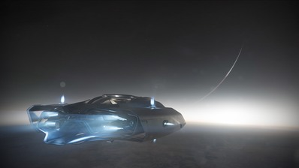
300i: Travel in style with this high-performance sleek touring ship.
315p: Traverse the ‘verse with this high-performance exploration focused ship.
325a: Origin’s sleek signature fighter, the 325 makes a great companion for finding your mark in style and sophistication.
350r: Origin’s sleek signature racer, the 350 makes a great companion for leaving your peers in the dust.
600i Explorer: The luxury yacht of Star Citizen, designed to explore in comfort and style with a vehicle bay.
85X: A luxury and sporty short-range runabout for pilot and passenger.
M50: Origin’s premier racer, small, fast and highly agile.

Nov 26 – Aegis Dynamics
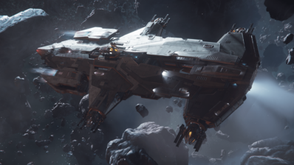
Avenger Stalker: A modified version of the Avenger, catering to bounty hunters with prison cells.
Avenger Titan: A former police ship with a cargo hold for light freight and courier abilities.
Avenger Titan Renegade: Special Edition of the Avenger Titan with custom livery and loadout geared for Arena Commander.
Avenger Warlock: A variant of the Avenger, armed with an EMPgenerator to disable enemies.
Eclipse: A sleek stealth bomber, armed with heavy torpedoes.
Gladius: An aged but agile light fighter with mid-range armament.
Gladius Valiant: Special Edition of the Gladius with custom livery and loadout geared for Arena Commander.
Hammerhead: A multi-crew corvette bristling with manned turrets designed to counter fighters.
Reclaimer: A heavy deep space salvage vessel to reclaim wrecks and derelicts.
Retaliator Bomber: A long-range anti capital ship bomber, covered in manned turrets and capable of launching size 9 torpedoes.
Sabre: Favoring agility over durability, this ship is light, sleek and deadly.
Sabre Comet: Special Edition of the Sabre with custom livery and loadout geared for Arena Commander.
Vanguard Hoplite: Long-range squad dropship with a turret gunner.
Vanguard Warden: Long-range heavy fighter with a turret gunner.

Nov 27 – Drake Interplanetary
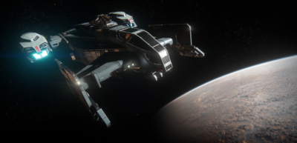
Buccaneer: A light fighter that sacrifices durability and an ejection seat for raw fire power.
Caterpillar: A heavy multicrew commercial freighter. Lightly armed, with superior cargo capacity.
Caterpillar Pirate: A heavy multicrew commercial freighter. Lightly armed, with superior cargo capacity and custom pirate livery.
Cutlass Black: Black is back. Drake’s multicrew Cutlass is highly versatile, with combat and cargo prowess.
Dragonfly Black: A two-seater grav-lev bike. Easily traverses rough terrain, or closes the distance in space.
Dragonfly Yellowjacket: A two-seater grav-lev bike. Easily traverses rough terrain or closes the distance in space with custom yellow livery.
Herald: No secret is safe, Drake’s Herald captures and stores information before leaving at blistering speed.

Nov 28 – Alien Manufacturers
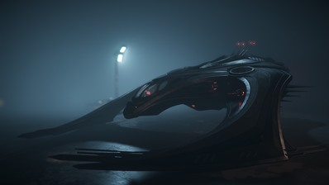
Khartu-al: Enigmatic, exotic and agile. The fragile Khartu-al excels at lateral thrust and maneuverability.
Nox: Sleek and fast, this gravity bike slices across rough terrain. Perfect for scouting and racing.
Nox Kue: Sleek and fast, this gravity bike slices across rough terrain. Perfect for scouting and racing with a bespoke Silver paintjob.
Vanduul Glaive: This Alien medium fighter replica drives fear with it’s ramming blades.
Vanduul Blade: Armed and Dangerous. This alien fighter slices through the air with it’s agility and shreds its foes.

Nov 29 – Musashi Industrial and Starflight Concern
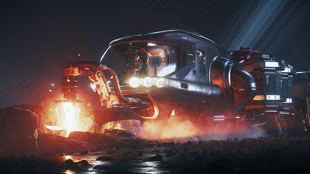
Freelancer: A multicrew cargo freighter, with turret and ordnance to deter those after it’s haul.
Prospector: A miner’s best friend, with a powerful mining laser and saddle bags to turn mineral to profit.
Razor: Cutting ahead of the competition, this sleek racer will give the others a run for pole position.
Razor EX: Stealth special edition of the Razor outfitted with signature-reducing materials and stealth components.
Razor LX: Special edition of the Razor features an overclocked engine, reduced maneuverability and armaments in exchange of straight-line speed.
Reliant Kore: A fusion of Xi’an and Human technology, this light freighter allows you to haul cargo with a friend.
Starfarer: Keep fleets on the move with this heavy refueler.
Starfarer Gemini: Keep fleets on the move with this heavy refueler, The Gemini version sacrifices capacity for armor and a missile launcher.

Nov 30 – Kruger/Argo/Tumbril/Consolidated Outland
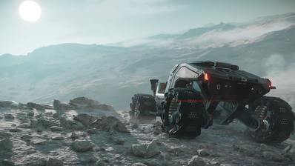
P-52 Merlin: Small, agile and comes with a sting. This snub fighter is fragile, but difficult to hit.
MPUV 1C: A small and unarmed utility runabout that transports cargo.
MPUV 1P: A small unarmed utility runabout tuned to transport personnel.
Cyclone: Stir up a storm with this robust two-seater buggy that can carry a little something in the back.
Cyclone AA: This two-seater buggy with EMP functionality is armed with an anti-air missile launcher to deter threats from above.
Cyclone RN: Unveils the fog of war, the recon variant of the Cyclone is mounted with a powerful scanner array.
Cyclone TR: Support ground infantry with this combat variant, equipped with a mounted turret to provide cover fire for ground operations.
Cyclone RC: Racing variant. It’s red, fast, and equipped with built-in nitro boost.
Mustang Alpha: Consolidated Outland’s premier ship for those wanting to push the limits a little more when starting out.
Mustang Beta: Home is where the heart is, the Beta offers comfortable living quarters for beginners roaming the frontier.
Mustang Delta: The Mustang Delta is armed with heavier weapons and rocket pods.
Mustang Gamma: Racing the competition? The additional engine loaded into the back will provide the competitive edge you need.

